Right To Rectification Procedure.

Contents

Purpose 2

Scope 2

Review 2

Right To Access Procedure 3

The Procedure. 4

# Purpose

The procedure would enable individuals to correct any inaccurate or incomplete personal data held by Metropolis. This ensures that the organization's records are accurate and up-to-date, which is vital for making informed decisions and maintaining operational efficiency.

# Scope

The procedure specified in this document applies to all information resources and assets that are owned by the company. And it’s applied to all staff, contractors, third parties, and to all other individuals or organizations who use, or support the use of the organization information processing environment. This procedure applies entirely in the organization.

# Review

The document shall be reviewed at least for each two months in case of major changes.

# Right To Rectification Procedure

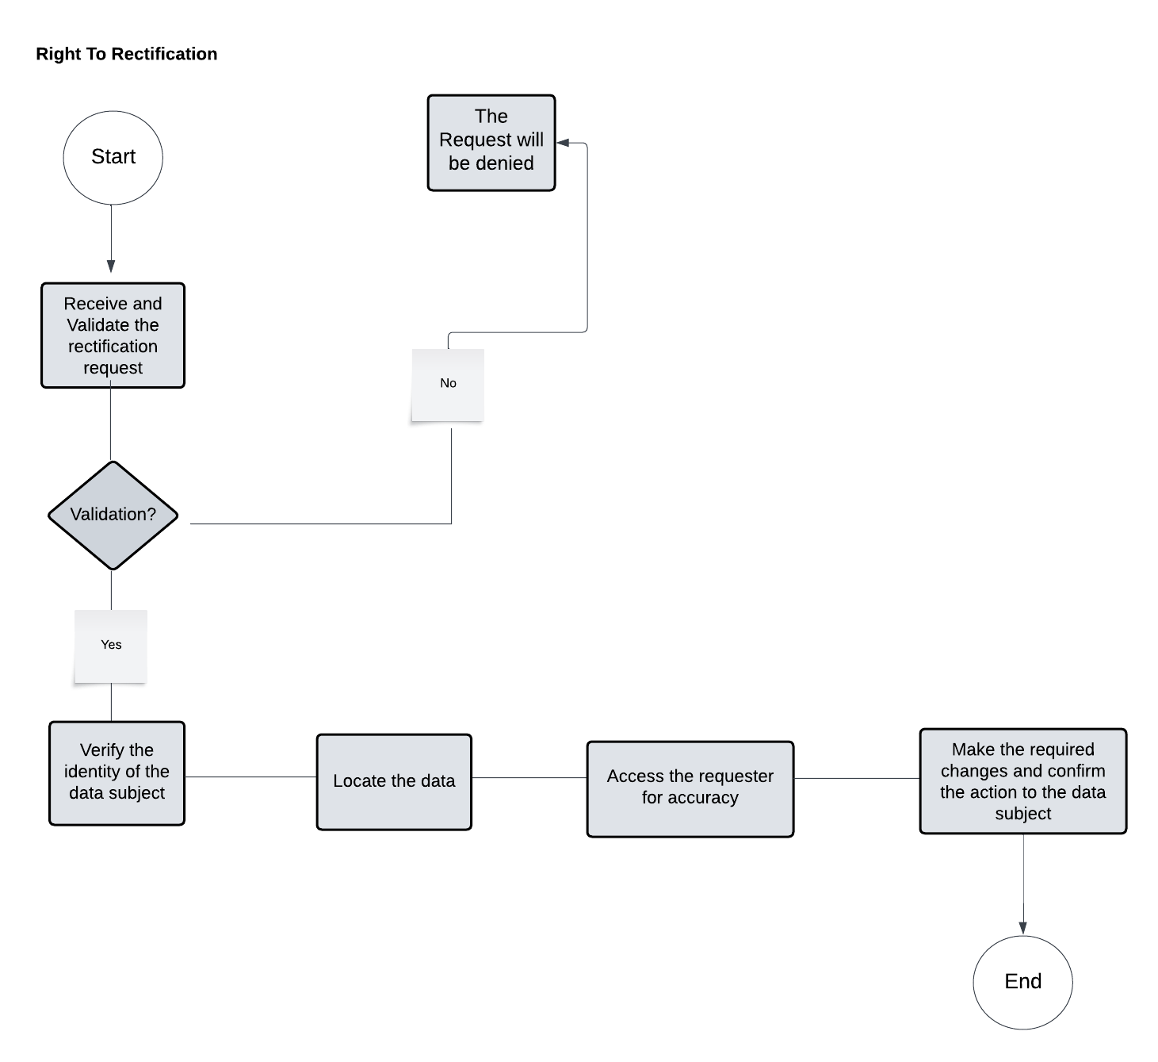

|  |  |  |
| --- | --- | --- |
| **The Activity ID** | **The Activity** | **Description on The Activity** |
| 1 | Receive and Validate the Rectification Request | Create a formal method for accepting requests (for example, a dedicated email address or an online form).  Ensure that the request includes all relevant information, such as the subject's identification and the precise data sought.  Check for completeness and legitimacy of the request.  with an emphasis on the specific inaccuracies or data elements the subject wants to rectify. |
| 2 | Verify the Identity of the Data Subject | Implement identity verification mechanisms (for example, demanding ID and comparing personal information).  Ascertain that the person making the request is the data subject or a legally authorized representative.  ensuring the requester has the right to request changes to the data. |
| 3 | Locate the Data | Pinpoint exactly where the specified data resides, considering all possible data sources. |
| 4 | Assess the Request for Accuracy and Legitimacy | Determine if the requested changes are factual and permissible (e.g., not changing legitimate historical records). |
| 5 | Make the Required Changes and Confirm the Action to the Data Subject | Update the data as requested, ensuring the changes are propagated through all data systems.  Inform the subject about the changes made and any impact on how the data will be used or shared. |

## The Procedure.